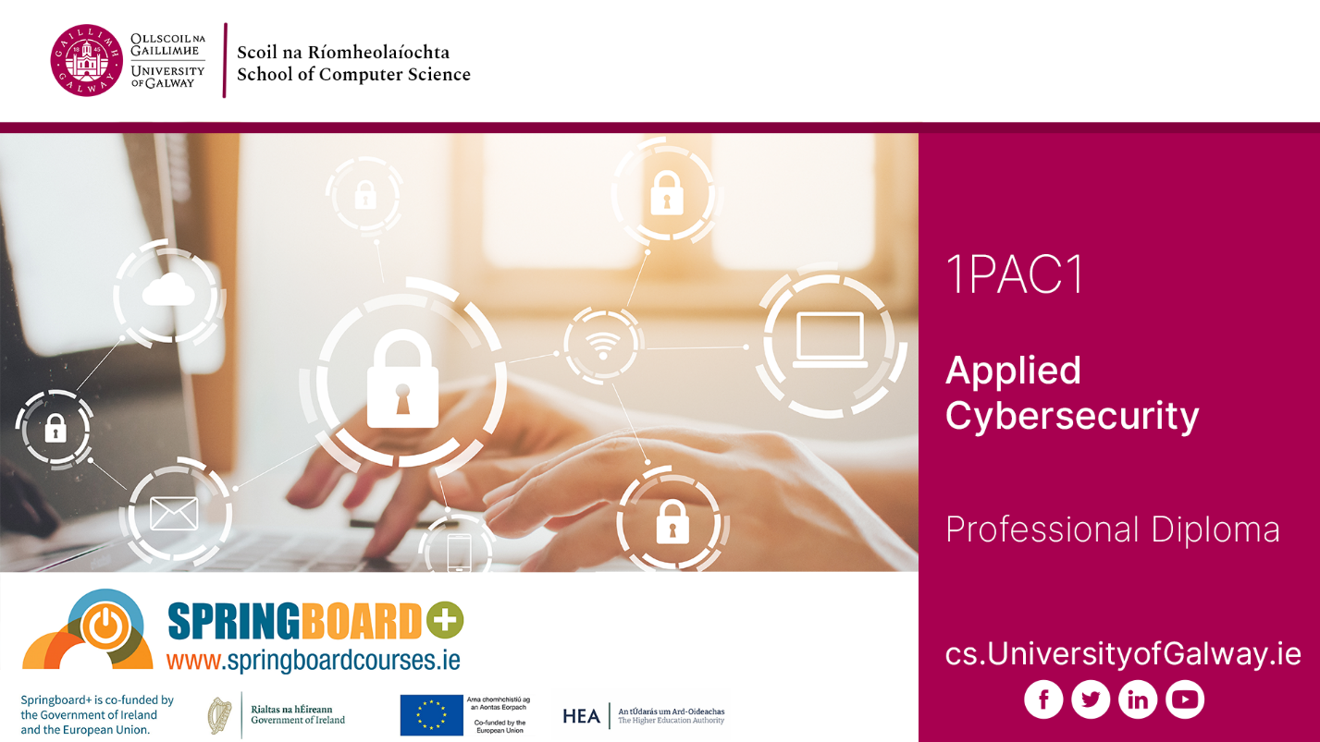

PROFESSIONAL DIPLOMA IN APPLIED CYBERSECURITY
(PART-TIME ONLINE)

Student Handbook

2026 | 2027

School of Computer Science, Computer Science (CS) Building, University of Galway

University of Galway School of Computer Science requires all students to have exclusive use of a laptop for use in lectures and labs, for home use of online materials and for participation in online sessions.

The minimum and recommend spec are detailed at: School of Computer Science Current Students Laptops.

We also operate a laptop loan scheme for students who cannot afford a suitable laptop (see same address).

Table of Contents
Section 1: Programme Description 4
Professional Diploma in Practical AI for Software Developers 4
Section 2: General Information 5
2.1 Academic Calendar 2026-2027 5
2.2 Key Contact Details 6
2.3 Registration 8
2.4 Activating your University of Galway Campus Account 9
2.5 Fees 9
2.6 Leave of Absence 12
2.7 Course Withdrawal 12
2.8 Student ID Cards 13
2.9 Parchment Digitary Services 13
2.10 Maps 13
2.11 Examinations 13
Results 14
Examination Timetables 14
Repeat, Appeals and Re-checks 14
Exam Board Sittings 15
Deferral of Exams 15
2.12 Student Services 15
2.13 Student Counselling 15
2.14 International Students 16
2.15 Computer Science Account and Swipe Card Access to Labs 16
2.16 DISC - Computer Programming Drop-In Support Centre 17
2.17 Canvas 17
2.18 Plagiarism 18
2.19 Ethics 18
2.20 Information Solutions and Services (ISS) 18
2.21 Career Development Centre 19
2.22 Out of Hours Working 19
2.23 Parking on Campus 19
2.24 Library 20
2.25 Module Description and Assessment 20
Modules – Semester I 20
Modules – Semester II 21
Modules – Semester III 22

Please note: This handbook is for information only and is correct at time of compilation to the best of our knowledge. However, processes and procedures may change throughout the academic year. Please visit the relevant websites and contact Administrative Offices for up-to-date information.

Section 1: Programme Description

Professional Diploma in Practical AI for Software Developers

This Professional Diploma in designed to equip software professionals with advances competencies essential for the rapid adoption and integration of AI technologies in software development workflows. This one-year, fully online, part-time programme includes machine learning, and overview of programming and tools for AI, the future of AI, and hands-on training on AI model deployment. Learners will gain industry-relevant experience through hands-on AI model development and deployment, including testing, debugging, and adopting AI-driven DevOps and CI/CD pipelines. Project-based learning will ensure learners acquire skills that are aligned with industry best practices, enhancing their employability in an AI-drive software landscape.

Feedback from industry partners such as Microsoft, Fidelity, and others continues to highlight the need for employees with skills in AI. Machine learning models are no longer solely the realm of researchers and ML Engineers. There is a strong need for software developers with the skills to use and understand how AI systems work to successfully integrate them into the products of the future.

Overall demand for AI and software development-related courses at both a regional and national level remains strong at University of Galway. AI is reshaping the landscape of software development, resulting in a rapid advancement that will redefine the industry. A recent study by Gartner, a US-based tech research firm, predicts that by 2027 80% of software engineers will need to upskill to remain relevant in the increasingly AI-driven world. To fill this gap, the Professional Diploma in Practical AI for Software Developers providers developers with advances AI skills necessary to build and deploy modern artificial intelligence in customer-facing projects.

Section 2: General Information

2.1 Academic Calendar 2026-2027

The Academic Calendar is available on the following website: Academic Term Dates.

Academic Year 2026-2027

Semester 1

Start of Teaching (UG years (excluding Year 1) and Postgraduate Taught programmes) | Monday 7th September 2026
End of Teaching all years | Friday 27th November 2026
Study Week (All Years, UG & PGT) | Monday 30th November - Friday 4th December 2026
Semester 1 Exams | Continuous Assessment**
Semester 2

Teaching (All Years, UG & PGT) | Monday 11th January – Friday 2nd April 2027
Easter | Good Friday 3rd April –  Easter Monday 6th April 2026
Field Trips | Monday 5th April – Friday 9th April 2027
Study Week (All Years, UG & PGT) | Monday 12th April – Friday 16th April 2027
Semester 2 Exams | Continuous Assessment**
Autumn Repeat Exams | Continuous Assessment**
**Note:
Online proctoring tool will be used throughout the Continuous Assessments for each module

Easter Holidays: Good Friday 26th March to Easter Monday 29th March 2027

Bank Holidays: Monday 26th October 2026 / Monday 1st February 2027 / Wednesday 17th March 2027 / Monday 3rd May 2027 / Monday 7th June 2027 / Monday 2nd August 2027

2.2 Key Contact Details

Programme Director

Programme |  | Programme Directors | Room | E:mail
Professional Diploma in Applied Cybersecurity | Dr Priyanka Verma |  | CSB-2019 | Priyanka.verma@universityofgalway.ie

Administrative and Technical Staff

Administrative Staff |  | Room | E:mail
Ms Deirdre King | School Manager | CSB-3013 | Deirdre.king@universityofgalway.ie
Ms Gail Cassidy | Programme Administrator | - | ICTskills@universityofgalway.ie
IT Technical Staff
Mr Peter O’Kane | Chief Technical Officer | CSB-3038 | Peter.okane@universityofgalway.ie
Mr Joe O’Connell | Senior Technical Officer | CSB-3037 | Joe.oconnell@universityofgalway.ie
Mr Pearse Carroll | Senior Technical Officer | CSB-3037 | pearse.carroll@universityofgalway.ie

The School of Computer Science is located in the Computer Science Building
Student Registry Help Desk
The Student Registry Help Desk provide the following services:
- Admissions, Registration, Exams and Conferring queries
- Prospectus pick up
- Replacement ID Cards
- Exam Transcript requests
- Course Withdrawal / Leave of Absence
- Validation and Stamping of Forms e.g. social welfare, medical card application
- Change of Name/ Change of Address requests
- Registration and Statements
- Employment and verification requests
Student Registry Help Desk: Location: Ground floor, Áras Uí Chathail, which is situated on the main campus. Tel: (091) 495999 / email: askregistry@universityofgalway.ie
Registered Students can visit the Front Desk service which is open Monday to Friday 9:30am-12:30pm and 1:30pm-4:00pm.

Useful Contact Numbers:
Student Registry Help Desk (091) 495999
ISS Help Desk (091) 495777
Admissions Office (091) 495999
Accommodation & Welfare Office (091) 493540
Disability Support Service (091) 492813
Fees Office (091) 492386
Health & Safety Office (091) 492678
Campus Security / Emergency (091) 493333
Student Counselling (091) 492484
Student Health Unit (091) 492604
Student’s Union Shop (091) 492411
General Emergency 999 / 112
Local Garda Station (091) 538 000
Hospital (UHG) (091) 524222
Samaritans 116 123 (freephone 24/7)

Student Support
For a summary of supports and services available to College of Science & Engineering students, please click into the following web link: Student Hub - University of Galway

College of Science & Engineering Student Support Officer
Kelly Moore is the Student Support Officer in the College of Science & Engineering, and provides support for students during their time at university. The role of the Student Support Officer is to provide confidential, non-judgmental support and an empathetic space for students to share their concerns. In addition, the Student Support Officer can offer personal support and advice on topics such as study planning, time management and any personal challenges that may compromise your ability to study. For further details please visit the following web link: COSE Student Support Officer - University of Galway
Student Support Officer contact email: studentsupportcse@universityofgalway.ie

2.3 Registration
Online registration opens on 18th August for postgraduate taught students. Details of relevant dates can be found on: New Student - University of Galway.

SELF-FUNDED STUDENTS ONLY: Students will receive an email from Registration before online registration opens inviting students to register online. Students should register as soon as possible for their programme and following receipt of an email from ISS, activate their University of Galway campus account (see paragraph 2.4 below). Further registration details can be found on: https://www.universityofgalway.ie/registration/.

SPRINGBOARD STUDENTS ONLY: Prior to course commencement in early September, your programme administrator will arrange for your details to be transferred from the Springboard platform to the University of Galway's student record system. Your programme administrator will then issue individual emails with your confidential student ID number enclosed - please look out for those communications and bear in mind that you will not be able to proceed to register for the programme until you also receive official ISS communication with confirmation of your University email address enclosed; please do not try to register before then. Confirmed incoming students from Springboard will also receive an email from Registration before online registration opens inviting them to register online with the University.

ALL STUDENTS: In case of any confusion, registration is not undertaken via your University e-mail account, it is done via the student portal on the University's student record system. Students should register as soon as possible for their programme, and following receipt of the above-mentioned email from ISS, ensure they correctly activate their University of Galway campus account including setting up MFA (see paragraph 2.4 below).

Any incoming student – either self-funded or Springboard - with an existing University of Galway student record from previous studies here must register under their existing student ID number. If you were a student of this University previously, you will need to get your ID numbers/student accounts merged before you register; contact Postgraduate Admissions via email to: postgradadmissions@universityofgalway.ie and quote your name, existing ID number, DOB, and the new ID number (supplied to you by your programme administrator, as applicable), and ask them to merge your student IDs/accounts before you proceed to register for this year. Further general registration details can be found on the following web link: Registration.

It is impossible to participate on any course of studies without going through the University's requirements for formal registration and account activation at the start of every academic year, and the onus is on the student to comply with all of the University's processes and deadlines in relation to same.

Access to the programme learning materials on the virtual learning environment Canvas will follow in the days after registration plus account activation/MFA setup has been successfully completed by each incoming student - there can be a delay of 24+ working hours before students get access to programme learning materials on Canvas. This is unavoidable and is due to the volume of registrations taking place across all University of Galway courses at this time of the year, hence students are advised to (a) register for their programme plus (b) activate their University of Galway campus account (see paragraph 2.4 below) as soon as possible.

2.4 Activating your University of Galway Campus Account
New students will receive a welcome email from ISS "Activating your new University of Galway campus account" which will be sent to a student’s personal email address (as listed in the application) following registration. Students must activate their Campus Account before they can register for a course. If students have not received an MFA email, please email: servicedesk@universityofgalway.ie

This email will provide students with a University of Galway email address and a temporary activation password. It also describes the steps new students need to take to activate their new University of Galway campus account. Immediately after activation, students should log in to their new University of Galway email. A campus account will allow students to access many important services during their time at University of Galway.

For new students, further details on the steps to follow to activate a new student campus account can be found on the following web link: ISS New Students Access.

For existing students, please follow the steps outlined in the following web link:
ISS Existing Student Access.

2.5 Fees
ALL STUDENTS: Information regarding course fees and deadlines for payment is available here. Fees may be paid either in full upon University registration or via two instalments by the Fees Office deadlines of 31st October (the campus-wide semester 1 fees payment deadline) and certainly no later than 31st January (the campus-wide deadline for full payment of all outstanding course fees).
How to view your details and how to pay:
The University has a convenient online payment system, which is accessible here.
When you log in to your account the “Pay Fees” link appears at the top right of the "COURSES" tab. You will be able to view the details of your fees billed and paid to date on this portal.
If you feel there are any errors on your record, please email the Fees Office directly with all necessary details so that it can be reviewed: fees@universityofgalway.ie
Please note that exam/course results will be withheld if there is an outstanding balance on your account and failure to pay your fees will entail additional late fee penalties plus exclusion from formal conferring (i.e. graduation) ceremonies on campus.

SELF-FUNDED STUDENTS ONLY:
- How do I pay to the University the course fees due from me as a self-funded student?
  - Pay fees - University of Galway
- How do I contact the Fees Office?
  - Fees Office Contact Details

SPRINGBOARD STUDENTS ONLY: Participation on a Springboard-funded course entails that students are obliged to undertake formal registration via their Springboard+ account in each semester when Springboard/HEA open that facility on their website. This applies to all students on this programme, irrespective of whether they initially applied via Springboard as either employed, unemployed, or returner applicants.

Funding to be paid to the University by the HEA under Springboard+ is strictly contingent upon all students registering on the Springboard website in each semester when prompted to do so in each academic year; this confirms to the HEA that the students are actively engaged in the course at the time of each registration in each semester, which then allows the HEA to release the corresponding fees payment tranche to the University under the contract of the Springboard+ scheme.

The HEA won't pay any fees to the University for any student who does not login to their Springboard account then register there when prompted in each semester.

Under the Springboard+ scheme, employed students are funded 90% by the HEA and then must pay the remaining 10% balance of course fees themselves. The University’s Fees Office maintain that those 10% balances should ideally be paid in full by 31st October (the campus-wide semester 1 fees payment deadline) and certainly no later than 31st January (the campus-wide deadline for full payment of all outstanding course fees).

Without exception, all Springboard students on this programme are required to complete the registration processes on Springboard’s platform within the set timeframe in each semester to ensure their continued participation on the programme. Students are strongly urged to heed the Springboard registration timeframes for each semester when advised of same via Canvas announcement by the programme administrator.

Failure to comply with this Springboard+ requirement will result in 100% course fees liability reverting to the individual Springboard student themselves:
- Student Fee Liability and Sanctions for Late or Non-Payment (screenshot below):

ALL STUDENTS: The potential implications of not complying as applicable with either the HEA’s registration requirements under the Springboard+ scheme (i.e. all Springboard students) and/or the Fees Office’s designated payment deadlines (i.e. all self-funded students plus all employed Springboard students who must pay 10% of the course fees to the University themselves) in accordance with the University’s fees policies outlined in the following links include:
- Springboard students only: Liability for up to 100% of all course fees due for the academic year in question
- All students i.e. self-funded plus Springboard students: Sanctions such as additional late fee payment penalties, withholding of formal programme results/transcripts, or exclusion from graduation
- Student Fees Regulations
- Student Fee Liability and Sanctions for Late or Non-Payment

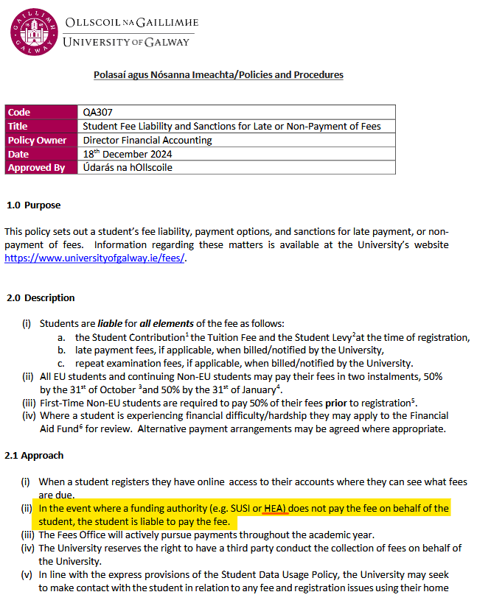

SPRINGBOARD STUDENTS ONLY: The best way for any student on any Springboard+ programme to prevent themselves being held personally liable for 100% of their course fees is to immediately comply with the Springboard registration timeframes in each semester, per the notifications that are issued via Canvas by the programme administrator.

The Springboard registration process for each semester involves four simple steps:
  - Log in to your account on the Springboard website.
  - Access your Applications list by clicking on your Username in the top right-hand side of the screen - you will see a drop-down menu. There you will see your Applications.
  - Click “Register” or “Re-register” (as applicable) for the programme in question.
  - Confirm Registration or Re-registration (as applicable) by clicking on “OK”.
Then the screen refreshes showing confirmed status.

As a reminder, the HEA deliberately block access to the Springboard website by anyone who is (a) outside the Republic of Ireland or who is (b) using a VPN.

Completing these registrations on the Springboard website when prompted to do so allows the HEA to make payments to the course provider and thus removes liability for payment of outstanding course fees from the individual student.

- How do I pay to the University the 10% course fees due from me as an employed participant under the Springboard+ scheme?
  - Pay fees - University of Galway
- How do I contact the Fees Office?
  - Fees Office Contact Details

2.6 Leave of Absence
Leave of Absence - Leave of Absence is an authorised and temporary break away from your programme. You can apply for Leave of Absence for numerous reasons, including medical or financial. Should you be considering applying for Leave of Absence, please contact your College School LOA Contacts and your Programme Director. The Leave of Absence Policy contains all relevant information, please read it carefully. Take a look as well at the Leave of Absence workflow diagram, it steps you through the process involved.

SPRINGBOARD STUDENTS ONLY: Springboard/HEA view any cessation of studies as the student not completing the programme in question and thereby forfeiting their Springboard-funded opportunity once and for all; they do not allow anyone to resume a funded place (i.e. with funding from Springboard still in place) following a break from their studies. If a student exits their programme and thus also exits Springboard funding for that academic year, liability for full course fees will revert to that individual student in the event they later decide to return and complete their programme in a future academic year (assuming the programme is still running at that time, which cannot be guaranteed).

2.7 Course Withdrawal
Course Withdrawal - If you find you must withdraw from the programme, please ensure you complete the University’s online withdrawal form no later than 31st October to ensure you leave with no impact on fees – link as follows:
- Postgraduate Students (Taught) online course withdrawal form
Please note: Course Withdrawal “Students remain liable for fees up until the date on which they formally submit a withdrawal form online.”

The withdrawal guidelines also recommend that students should contact the relevant staff member for their College/School; for students on programmes run by the School of Computer Science the staff member to contact is the College of Science & Engineering’s Student Support Officer Kelly Moore – web link as follows: Student Support Officer. We recommend that you reach out to Kelly for advice and support as soon as possible.

Once the formal withdrawal has been processed on the University's systems, we will then update your status on Springboard's records to note for them that you have formally withdrawn from the programme via the University’s records. Students who have formally withdrawn should also contact Springboard directly via email springboard@hea.ie to advise them of their formal withdrawal from the programme as well.

Please note: Course Withdrawal

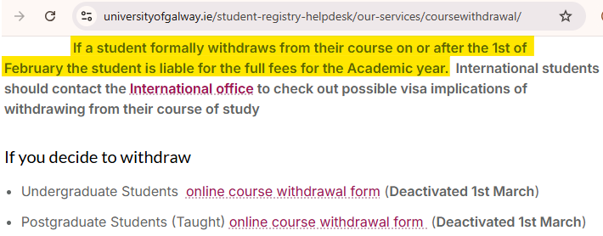

2.8 Student ID Cards
Students can collect their ID cards from the Student Registry Helpdesk, first floor, Áras Uí Chathail from the start of term: ID Cards - University of Galway. Alternatively, students can request their ID card to be posted - please email registration@universityofgalway.ie, note your ID number in the correspondence. To ensure your ID card reaches your address, please ensure that your term and home address on your student profile are correct.

Note: There is a fine of €25 if you do not have your Student ID card for verification of identity and registration in the exam hall.

2.9 Parchment Digitary Services
Parchment Digitary Services is a trusted, secure cloud platform that helps University students from around the world to access and share their verified academic documents online. This service will be used for official documents requests and letters from the Student Registry Helpdesk including: registration statements, course completion statement, transcript of results etc. Further details can be found at the following web link: Parchment Digitary Services - University of Galway

2.10 Maps
University of Galway Campus maps can be located on the University’s website: Campus maps

2.11 Examinations
Results are no longer posted to the candidate's home address, they are now made available through the Parchment Delivery Service. These results will also be available on-line (following Semester 2 examinations)**. All other results will be available online only (following Semester 2 examinations).

Further copies of result transcripts can be obtained from the Student Registry Helpdesk.
Click on the link for info on how to register an address change. Please note you must allow 2 weeks for your change of address request to be processed.

** Some postgraduate results are not available online - check Examination Results Inquiry for a full listing of course instances available online.

Results
Results will NOT be given on the telephone to candidates, or to anyone acting on their behalf.
Official Exam results release dates are available from the following Exams Office web link: Exam Results.

Examination Timetables
Examination timetables may be viewed on the University of Galway web page link: Exam Timetables. Students personalised timetables will be available on the above link on a date to be advised by the Exams Office.

Timetables will NOT be posted to students.

Please be advised:
- Check the Amendments web page OFTEN as changes may occur up to day of exam.
- Revisions to timetables will be published only online.
- Revisions to timetables will not be posted to individuals or appear on personal timetables.

Repeat, Appeals and Re-checks
Where a repeat exam sitting is available for your course and if you fail the first sitting of a formal written examination, you are automatically listed to sit the repeat exam at the second sitting e.g. if you fail a Semester 2 Summer exam, you are automatically listed to sit the repeat exam in the Autumn. If you fail an exam/module which was not a formal written examination (e.g. essay, project, continuous assessment), please contact your Programme Director to discuss your options.

Springboard will not cover any repeat fees (either for individual repeat exams or for repeating an entire academic year) for any student under any circumstances, as that is wholly a matter between the student and the University and has nothing to do with Springboard.

All students who must repeat an exam (because of having failed it at the first sitting) can be charged a repeat exam fee by the University’s Examinations Office at the second sitting, which is payable by the student themselves - see link for further details: Repeat Fee - University of Galway

Please be advised that all repeat exams are capped at 40% in accordance with University policy on Exam Repeats and Capping.
Note: Approved deferred exams are not capped.

Strict deadlines apply for appeals and re-checks and completed online application forms must be submitted to the Examinations Office by the relevant deadlines as detailed on the website links as follows: Exam Appeals and Exam Rechecks. A fee must be lodged with both the Appeal and Re-check Forms. Fees are refunded if the outcome is positive. Further detailed information is provided in the above links.

Exam Board Sittings
The examination boards sit in June, September and October where relevant examination, project and theses grades will be processed by the College of Science and Engineering.

Deferral of Exams
A guide for exam deferrals is available at the following web link: Deferrals. This guide is to assist students with the process and provides a direct link to the College of Science & Engineering’s online specific Deferral Form.

2.12 Student Services
Coming to University is a major milestone in your life and a point of changeover in your life. You are facing into some challenges and many opportunities. You will encounter the enjoyment and challenges of independence and decision-making and responsibility for your own well-being and lifestyle.

Student Services is a team that are core to the personal and academic development of students. Student Services is under the management of the Vice President for the Student Experience. Student Services is committed to enhancing the individual student experience by providing an excellent service which supports the holistic development of the person, thereby enabling each student to achieve their full academic potential. Through valuing, recognising and supporting each staff member and by forging strong alliances within the University Community, Student Services will assist University of Galway to become a truly Student-Centred University.

Student Services provides many services as follows:
- Access Centre; Career Development Centre; Student Societies; Welfare and Wellbeing.

Further detailed information and contact details on all the Student Services offered by University of Galway may be found at the following website: Student Services.

2.13 Student Counselling
The counselling service is part of a network of support services offered by University of Galway. It provides professional counselling, which is free and confidential to all students of University of Galway. Life as a student is exciting and challenging, an achievement usually gained after much hard work and preparation. It can also be stressful at times. You may find you are experiencing personal difficulties which are affecting your ability to study and to take full advantage of the opportunities available to you at University of Galway. This is where student counselling can help. Student counselling are a team of qualified and experienced counsellors and psychotherapists. The service operates within the Code of Ethics and Practice agreed by their respective accrediting bodies including IACP, IAHIP and PSI. The services provided include:
    - Pre-counselling assessment, individual counselling, and psychotherapy
    - Group work
    - Information and referral
    - A consultation service for those who may have concerns about a student.
Further information including available online services and emergency contact details can be located on the following web link: Counselling and Wellbeing.

Counselling Services: Location: No. 5 Distillery Road, University of Galway
Direct Tel: (091) 492484 Ext. 2484
E-mail: counselling@universityofgalway.ie

2.14 International Students
The Global Galway Office provide advice, information and support service for all International Students. For incoming international students, information is available on the following web link: Global Galway - University of Galway

All international students are strongly encouraged to attend English for Academic Purposes (EAP) classes which are specifically designed to equip international students with specific English skills to help them with their studies. Please refer to English Language Centre for more details.

The Global Student Officer, Ms. Louise Kelly, may be contacted at Global Galway, University of Galway, Tel 353 91 493581, E-mail: louise.kelly@universityofgalway.ie. Louise acts as an identifiable point of contact with the various Student Services in the University to ensure that any problems of adjustment are minimised. Louise helps international students adjust as quickly as possible to their new environment, so that they can derive maximum benefit and enjoyment from their life at University of Galway.

2.15 Computer Science Account and Swipe Card Access to Labs
The School of Computer Science has several undergraduate and postgraduate rooms which are available for use by our students. The rooms have hot swap desks, with laptop docking stations allowing use of external monitor, keyboard, mouse and the high-speed network.

Students must provide their own Laptops. All students who are taking a module/course with the School of Computer Science are entitled to use the open access labs in the CS Building outside of scheduled timetable use (Note: CSB-G001 is available to all University of Galway students using main University of Galway account). Depending on their course, students may also have swipe card access to further project rooms in the CS Building. New students must bring their ID card to the Computer Science Technical Officers in CSB-3037 who will enable access.

Computer Science students are also given access to print on our shared printers, and to use our web and database servers which can be used for course or project work. To gain access to these resources, students will be given Computer Science accounts automatically after a student registers for one of our modules/courses, and students will receive an email to their University of Galway email to indicate the account is ready for use. The initial password is included in the email. Students can login to our intranet to setup the web/database/linux resources using the following web link: School of Computer Science Intranet Login

Students who have issues with their Computer Science computer account, docking stations, monitors or swipe card access in the Computer Science Building should log a call to Computer Science Technical Officers by emailing: support@cs.universityofgalway.ie. Useful links for further related information can be found on the following web link: School of Computer Science Current Students.

Students who have issues with their main University of Galway account, Wi-Fi, Canvas, personal laptops or any PC/printer on the rest of campus should refer to the University of Galway helpdesk website as follows: ISS Services for Students.

2.16 DISC - Computer Programming Drop-In Support Centre
Computer DISC is a Computer Programming Drop-In Support Centre for all University of Galway students who are taking any programming/software development courses. The DISC is a free service that supports all students with their self-directed learning in computing topics at all years and levels in University of Galway. The centre is located in room CSB-1001 on 1st floor of the Computer Science (CS) Building.

What services does Computer DISC provide to students?
- Facilities for students to sit and work on programming problems
- One-to-one advice and support for students, and focused small group tutorials
- Books, courseware, web links, and other learning resources for programming students
- A website with information and an email service for all queries
- Advice for students who wish to learn new programming languages autonomously
- Assistance with new technologies for project work such as Final Year Projects

2.17 Canvas
Canvas is the Virtual Learning Environment (VLE) used at University of Galway. Canvas is a modern, user-friendly VLE that allows students to access learning materials, reading lists, assessment information and other course-related content.

When a student registers for a course or module with the University of Galway, they are automatically enrolled on the corresponding course on Canvas. Enrolments are recognised by Canvas within 24 hours of registration. If students have problems accessing Canvas, they should contact the Library and IT Service Desk. The Service Desk can assist students with queries regarding problems with their password, e-mail account or logging in to Canvas.

If students are unable to see courses when they log into Canvas, they will need to check their registration statement to ensure they are correctly registered. Within Canvas, University of Galway students have access to 24x7x365 support via the Help menu. This Canvas support team can answer most queries related to the Canvas environment including how to submit assignments, how to see the gradebook, and where to access course materials. They also provide advice on how Canvas features can be used.

2.18 Plagiarism
Plagiarism refers to copying another author’s work without due reference or acknowledgement of the author. Plagiarism is not acceptable. It is essential that the candidate acknowledge other people’s work, when used by the student. The submitted work must be prepared by the candidate alone, and must be the result of the candidate’s own effort, skills and knowledge. It is unacceptable for candidates to knowingly permit others to copy their work. Self-plagiarism (re-using own previously submitted content and passing it off as “new”) is also not permitted. It is also not permitted to submit content for assessment which has been produced using Artificial Intelligence and claiming it as your own work. University of Galway has a strict code of practice for dealing with plagiarism, please refer to the following link for further details: Academic Integrity.

2.19 Ethics
All research must be conducted in line with appropriate ethical standards. As part of your capstone project/thesis, you must therefore consider ethical issues before conducting any research. The University provides research ethics training through an Epigeum course, and all students are required to complete this course as part of their capstone project module. This includes, but is not limited to, obtaining informed consent, and ensuring confidentiality and data protection, for any research involving human participants.

2.20 Information Solutions and Services (ISS)
ISS aim to provide students with access to the ICT facilities which they need to succeed in their studies at University of Galway. These facilities include high speed Internet access, a University of Galway email account, access to the resources of the James Hardiman Library and assist with accessing Canvas, the virtual learning environment. These services are accessible from the on-campus PC suites and from suitably equipped laptops using the on-campus wireless network. A Campus Account (CASS) provides students access using a single User ID and Password to all computing services, other than email. To activate a Campus Account (see 2.4 above), students should follow the instructions as outlined in the following web link: Student Access Instructions.

ISS Service Desk: Location: Ground floor of the James Hardiman Library
Contact by raising a service ticket: Service Desk Ticketing System
Direct Phone: (091) 495777 or the Library & I.T. Service Desk: (091) 493399

2.21 Career Development Centre
The Career Development Centre provides students at University of Galway with a quality career guidance and information service focused on facilitating and empowering students to manage their own career development and empowering students to make successful transitions towards fulfilling careers.

Details of the services provided to students by the Career Development Centre include:
Guiding students in their career journey through:
- One-to-one career guidance
- Career seminars and events
- Psychometric testing
- Dedicated careers information hub for students (on-campus and virtual)
- Self-guided modules
Connecting students with employers through:
- Jobs fairs and employer events
- Job vacancy system
- Networking opportunities
Helping students to compete in the jobs market to the best of their ability through:
- CV workshops, e-learning, and unlimited AI feedback
- Interview skills workshops, e-learning, and software to practice and improve
- Applications advice: including Postgraduate and Job Applications
- Employment skills workshops and employability award
Career Development Centre: Location: Arts/Science Building (1st Floor)
Tel: (091) 493589
Email: careers@universityofgalway.ie

2.22 Out of Hours Working
Out of hours work refers to all University operations conducted outside normal hours.
For up to date details on the University’s Safety Statement Policy and Out of Hours Working, please click on the following web link: University of Galway Safety Statement

2.23 Parking on Campus
Parking spaces in University of Galway fall into several categories:
- Staff Only; Student Only; Shared use (staff & student permit holders); Visitor/non-permit holder; Pay-and-display/Pay by Phone (P&D) spaces; "Reserved" spaces and loading bays.
Student parking permits are available for registered students, details as below.

To purchase/renew your Student Parking Permit carefully read the instructions contained in the following guide ‌Parking Permit Application Guide then visit the Online Payment System to book your permit.

If you park in a "Pay and Display" space, you must buy a ticket from the nearby machines or use the Pay by Phone option and display your ticket on your dashboard face up, regardless of what other type of permit you might have. If you buy a P&D ticket, you can only park in spaces marked with blue lines and text (“P&D/Í&T”).

A park and ride service operates from Dangan car park. Further information and timetable details are available from: Parking & Transport - University of Galway.

Parking at University of Galway is operated by APCOA Ireland. If you have a parking related query, please email: Ireland.permits@apcoa.ie / Tel: 0818 462899.

2.24 Library
The Student ID card also acts as a Library card. Students must have a current Student ID card in order to gain entrance to the Library. Details on the services provided by the library are available at About - University of Galway. The Library and IT Service Desk are located on the ground floor of the library and provides advice and support to students on both Library and IT services (e.g., User ID/passwords, book loans, printing Wi-Fi access).

2.25 Module Description and Assessment

Modules – Semester I

1PSD1 | Modules
Core | CT5223 Cybersecurity Fundamentals (CA) | Credits: 5
Core | CT5229 Programming and Tools for Artificial Intelligence (CA) | Credits: 5

CT5223 Cybersecurity Fundamentals (CA)
This module covers the importance of cybersecurity, awareness, data confidentiality, and appropriate practices when using cyberspace. In this module, learners are taken through every aspect of cybersecurity, explaining why personal and organisational data should be protected. It covers foundational knowledge in all aspects of security in the cyber world, including information security, systems security, network security, mobile security, physical security, data protection laws, and Cybersecurity frameworks. Learners engage in hands-on learning through labs to explore technologies, procedures, and mitigation strategies. They gain practical experience with the defense tactics that organisations employ to ensure security, bridging theory with real-world application.

Assessment: First Sitting: Continuous Assessment 100%
Second Sitting: Continuous Assessment 100%

CT5229 Programming and Tools for Artificial Intelligence (CA)
This module is about programming and computational tools required for artificial intelligence. It uses the Python language as the main vehicle, but focusses on conceptual material rather than just the language itself. It moves fast through introductory Python workings. It covers several important Python libraries in detail, especially for numerical computing, machine learning, plotting, graphs. It discusses approaches to building re-usable, high quality code but not software engineering per se. It also visits some extra topics such as version control and introduction to the R language for statistics. The module is core for the University of Galway MSc in Artificial Intelligence (MScAI) Part-time (online) and Full-time (classroom). The syllabus and assessment will be the same for both.

Assessment: First Sitting: Continuous Assessment 100%
Second Sitting: Continuous Assessment 100%

Modules – Semester II

1PSD1 | Modules
Core | CT5224 Web Applications Security (CA) | Credits: 5
Core | CT5225 Cybersecurity Tools and Techniques (CA) | Credits: 5

CT5224 Web Applications Security (CA)
This module introduces learners to the theory and practice of web application development with a focus on security. Students will explore, analyze, and assess common web vulnerabilities to identify and apply effective countermeasures. By studying the tools and techniques used in web attacks, learners will gain the knowledge needed to strengthen web applications against threats.

Assessment: First Sitting: Continuous Assessment 100%
Second Sitting: Continuous Assessment 100%

CT5225 Cybersecurity Tools and Techniques (CA)
The purpose of this module is to facilitate the learners in understanding and practicing secure software development lifecycles (DevSecOps) using different libraries and tools. It enables learners to understand tools for penetration testing comprehensively. It will also provide cryptography concepts and mechanisms, including how they can be applied, individually and in combination, to build secure development operations.

Assessment: First Sitting: Continuous Assessment 100%
Second Sitting: Continuous Assessment 100%

Modules – Semester III

1PSD1 | Module
Core | CT5226 Capstone Cybersecurity Project | Credits: 10

CT5226 Capstone Cybersecurity Project
This module connects academic knowledge with real-world application, equipping students with practical learning either through industry placement (internships) or capstone projects. It emphasises research-based practical learning to enhance problem-solving and cybersecurity skills.

Assessment: First Sitting: Project 100%

