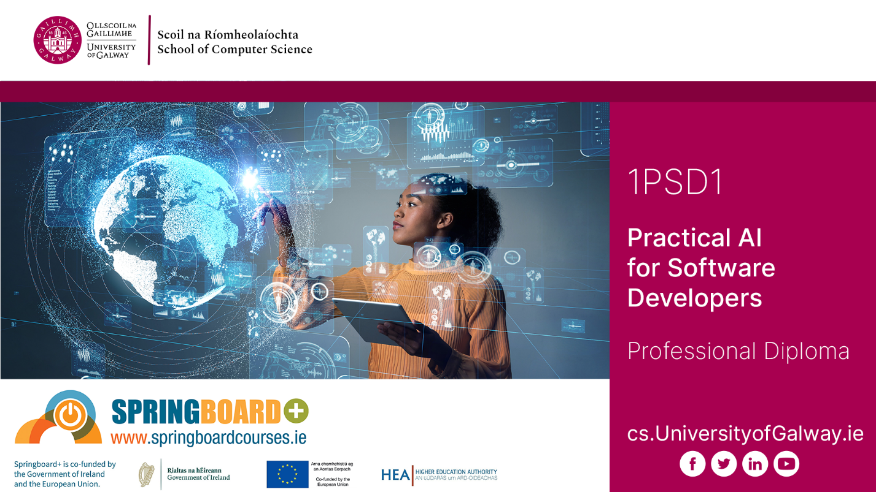

PROFESSIONAL DIPLOMA IN
PRACTICAL AI FOR SOFTWARE DEVELOPERS
(PART-TIME ONLINE)

Student Handbook 2025 | 2026

School of Computer Science, Computer Science (CS) Building, University of Galway

University of Galway School of Computer Science requires all students to have exclusive use of a laptop for use in lectures and labs, for home use of online materials and for participation in online sessions.

The minimum and recommend spec are detailed at https://www.universityofgalway.ie/science-engineering/school-of-computer-science/currentstudents/laptops/.

We also operate a laptop loan scheme for students who cannot afford a suitable laptop (see same address).

Table of Contents

Section 1: Programme Description 4
Professional Diploma in Practical AI for Software Developers 4
Section 2: General Information 5
2.1 Academic Calendar 2025-2026 5
2.2 Key Contact Details 6
2.3 Registration 8
2.4 Activating your University of Galway Campus Account 9
2.5 Fees 9
2.6 Leave of Absence 12
2.7 Course Withdrawal 12
2.8 Student ID Cards 13
2.9 Parchment Digitary Services 13
2.10 Maps 13
2.11 Examinations 14
2.12 Student Services 15
2.13 Student Counselling 16
2.14 International Students 16
2.15 Computer Science Account and Swipe Card Access to Labs 17
2.16 DISC - Computer Programming Drop-In Support Centre 17
2.17 Canvas 18
2.18 Plagiarism 18
2.19 Information Solutions and Services (ISS) 19
2.20 Career Development Centre 19
2.21 Out of Hours Working 20
2.22 Parking on Campus 20
2.23 Library 20
2.24 Module Descriptions and Assessments 21
Modules – Semester I 21
Modules – Semester II 22
Modules – Semester III 22

Please note: This handbook is for information only and is correct at time of compilation to the best of our knowledge. However, processes and procedures may change throughout the academic year. Please visit the relevant websites and contact Administrative Offices for up-to-date information.

Section 1: Programme Description

Professional Diploma in Practical AI for Software Developers

This Professional Diploma in designed to equip software professionals with advances competencies essential for the rapid adoption and integration of AI technologies in software development workflows. This one-year, fully online, part-time programme includes machine learning, and overview of programming and tools for AI, the future of AI, and hands-on training on AI model deployment. Learners will gain industry-relevant experience through hands-on AI model development and deployment, including testing, debugging, and adopting AI-driven DevOps and CI/CD pipelines. Project-based learning will ensure learners acquire skills that are aligned with industry best practices, enhancing their employability in an AI-drive software landscape.

Feedback from industry partners such as Microsoft, Fidelity, and others continues to highlight the need for employees with skills in AI. Machine learning models are no longer solely the realm of researchers and ML Engineers. There is a strong need for software developers with the skills to use and understand how AI systems work to successfully integrate them into the products of the future.

Overall demand for AI and software development-related courses at both a regional and national level remains strong at University of Galway. AI is reshaping the landscape of software development, resulting in a rapid advancement that will redefine the industry. A recent study by Gartner, a US-based tech research firm, predicts that by 2027 80% of software engineers will need to upskill to remain relevant in the increasingly AI-driven world. To fill this gap, the Professional Diploma in Practical AI for Software Developers providers developers with advances AI skills necessary to build and deploy modern artificial intelligence in customer-facing projects.

Section 2: General Information

2.1 Academic Calendar 2025-2026

The Academic Calendar is available on:
https://www.universityofgalway.ie/registry/academic-term-dates/#d.en.186426

Academic Year 2025-2026

Semester 1

Start of Teaching (UG years (excluding Year 1) and Postgraduate Taught programmes) | Monday 8th September 2025
End of Teaching all years | Friday 28th November 2025
Study Week (All Years, UG & PGT) | Monday 1st December - Friday 5th December 2025
Semester 1 Exams | Continuous Assessment**
Semester 2

Teaching (All Years, UG & PGT) | Monday 12th January – Thursday 2nd April 2026
Easter | Good Friday 3rd April –  Easter Monday 6th April 2026
Field Trips | Tuesday 7th April – Friday 10th April 2026
Study Week (All Years, UG & PGT) | Monday 13th April – Friday 17th April 2026
Semester 2 Exams | Continuous Assessment**
**Note:
Online proctoring tool will be used throughout the Continuous Assessments for each module

Easter Holidays: Good Friday 3rd April to Easter Monday 6th April 2026

Bank Holidays: Monday 27th October 2025 / Monday 2nd February 2026 / Tuesday 17th March 2026 / Monday 4th May 2026 / Monday 1st June 2026 / Monday 3rd August 2026

2.2 Key Contact Details

Programme Directors

Programme |  | Programme Directors | Room | E:mail
Professional Diploma in Practical AI for Software Developers | Dr Priyanka Verma  Dr Joseph Lemley |  | CSB-2019 | Priyanka.verma@universityofgalway.ie  Joseph.lemley@universityofgalway.ie

Technical and Administrative Staff

Administrative Staff |  | Room | E:mail
Ms Deirdre King | School Manager | CSB-3013 | Deirdre.king@universityofgalway.ie
Ms Gail Cassidy | Programme Administrator | - | ICTskills@universityofgalway.ie
IT Technical Staff
Mr Peter O’Kane | Chief Technical Officer | CSB-3038 | Peter.okane@universityofgalway.ie
Mr Joe O’Connell | Senior Technical Officer | CSB-3037 | Joe.oconnell@universityofgalway.ie
Mr Pearse Carroll | Senior Technical Officer | CSB-3037 | pearse.carroll@universityofgalway.ie

The School of Computer Science is located in the Computer Science (CS) Building, Floor 3
For directions to the CS Building please click (Ctrl+Click) here
Student Registry Help Desk
The Student Registry Help Desk provide the following services:
- Admissions, Registration, Exams and Conferring queries
- Prospectus pick up
- Replacement ID Cards
- Exam Transcript requests
- Course Withdrawal / Leave of Absence
- Validation and Stamping of Forms e.g. social welfare, medical card application
- Change of Name/ Change of Address requests
- Registration and Statements
- Employment and verification requests
Student Registry Help Desk: Location: Ground floor, Áras Uí Chathail, which is situated on the main campus. Tel: (091) 495999 / askregistry@universityofgalway.ie
Registered Students can visit the Front Desk service which is open Monday to Friday 9:30am-12:30pm & 1:30pm-4:00pm. Web link for further details as follows: https://www.universityofgalway.ie/student-registry-helpdesk/

Useful Contact Numbers (http://www.universityofgalway.ie/about-us/contact-us/)

Student Registry Help Desk (091) 495999
ISS Help Desk (091) 495777
Admissions Office (091) 495999
Accommodation & Welfare Office (091) 493540
Disability Support Service (091) 492813
Fees Office (091) 492386
Health & Safety Office (091) 492678
Campus Security / Emergency (091) 493333
Student Counselling (091) 492484
Student Health Unit (091) 492604
Student’s Union Shop (091) 492411
General Emergency 999 / 112
Local Garda Station (091) 538 000
Hospital (UHG) (091) 524222
Samaritans 116 123 (freephone 24/7)

Student Support
For a summary of supports and services available to College of Science & Engineering students, please click (Ctrl+Click) here

College of Science & Engineering Student Support Officer
Kelly Moore is the Student Support Officer in the College of Science & Engineering, and provides support for students during their time at university. The role of the Student Support Officer is to provide confidential, non-judgmental support and an empathetic space for students to share their concerns. In addition, the Student Support Officer can offer personal support and advice on topics such as study planning, time management and any personal challenges that may compromise your ability to study. For further details please visit the following web link: COSE Student Support Officer - University of Galway
Student Support Officer: studentsupportcse@universityofgalway.ie

2.3 Registration
Online registration opens on 19th August for postgraduate taught students. Details of relevant dates can be found on: (New Student - University of Galway). Prior to course commencement in early September, your programme administrator will arrange for your details to be transferred from the Springboard platform to the University of Galway's student record system. Your programme administrator will then issue individual emails with your confidential student ID number enclosed - please look out for those communications and bear in mind that you will not be able to proceed to register for the programme until you also receive official ISS communication with confirmation of your University email address enclosed; please do not try to register before then.

Anyone with an existing University of Galway student record from previous studies here must register under their existing student ID number. If you were a student of this University previously, you will need to get your ID numbers/student accounts merged before you register; contact Postgraduate Admissions via postgradadmissions@universityofgalway.ie and quote your name, existing ID number, DOB, and the new ID number (supplied to you by your programme administrator, as applicable), and ask them to merge your student IDs/accounts before you proceed to register for this year.

Confirmed incoming students from Springboard will also receive an email from Registration before online registration opens inviting them to register online with the University. In case of any confusion, registration is not undertaken via your University e-mail account, it is done via the student portal on the University's student record system. Students should register as soon as possible for their programme, and following receipt of the above-mentioned email from ISS, ensure they correctly activate their University of Galway campus account including setting up MFA (see paragraph 2.4 below).

Further general registration details can be found on: https://www.universityofgalway.ie/registration/.

It is impossible to participate on any course of studies without going through the University's requirements for formal registration and account activation at the start of every academic year, and the onus is on the student to comply with all of the University's processes and deadlines in relation to same.

Access to the programme learning materials on the virtual learning environment Canvas will follow in the days after registration plus account activation/MFA setup has been successfully completed by each incoming student - there can be a delay of 24+ working hours before students get access to programme learning materials on Canvas. This is unavoidable and is due to the volume of registrations taking place across all University of Galway courses at this time of the year, hence students are advised to (a) register for their programme plus (b) activate their University of Galway campus account (see paragraph 2.4 below) as soon as possible.

2.4 Activating your University of Galway Campus Account
New students will receive a welcome email from ISS "Activating your new University of Galway campus account" which will be sent to a student’s personal email address (as listed in your application) following registration. You must activate your Campus Account before you can register for your course. If you haven't received your MFA email, please email servicedesk@universityofgalway.ie

This email will provide students with a University of Galway email address and a temporary activation password. It also describes the steps new students need to take to activate their new University of Galway campus account. Immediately after activation, log in to your new University of Galway email. A campus account will allow students to access many important services during their time at University of Galway.

For new students, further details on the steps to follow to activate a new student campus account can be found here: https://www.universityofgalway.ie/information-solutions-services/studentrecordssystem/studentaccess/newstudents/

For existing students, please follow the steps outlined in the following link:
https://www.universityofgalway.ie/information-solutions-services/studentrecordssystem/studentaccess/existingstudents/

2.5 Fees
Participation on a Springboard-funded course entails that students are obliged to undertake formal registration via their Springboard+ account in each semester when Springboard/HEA open that facility on their website. This applies to all students on this programme, irrespective of whether they initially applied via Springboard as either employed, unemployed, or returner applicants.

Funding to be paid to the University by the HEA under Springboard+ is strictly contingent upon all students registering on the Springboard website in each semester when prompted to do so in each academic year; this confirms to the HEA that the students are actively engaged in the course at the time of each registration in each semester, which then allows the HEA to release the corresponding fees payment tranche to the University under the contract of the Springboard+ scheme.

The HEA won't pay any fees to the University for any student who does not login to their Springboard account then register there when prompted in each semester.

Under the Springboard+ scheme, employed students are funded 90% by the HEA and then must pay the remaining 10% balance of course fees themselves. The University’s Fees Office maintain that those 10% balances should ideally be paid in full by 31st October (the campus-wide semester 1 fees payment deadline) and certainly no later than 31st January (the campus-wide deadline for full payment of all outstanding course fees).

The potential implications of not complying with both the HEA’s registration requirements under Springboard+ and/or the Fees Office’s designated payment deadlines (i.e. for employed students who must pay 10% of the course fees themselves) include liability for up to 100% of all course fees due for the academic year in question plus possible sanctions such as additional late payment penalties, withholding of formal programme results (i.e. transcripts), or exclusion from graduation, in accordance with the University’s fees policies outlined in the following links:

- https://www.universityofgalway.ie/student-fees/regulations/
- https://www.universityofgalway.ie/media/fees/files/QA307-Student-Fee-Liability-and-Sanctions-for-late_non-payment.pdf

Without exception, all students on this programme are required to complete the registration processes on Springboard’s platform within the set timeframe in each semester to ensure their continued participation on the programme. Students are strongly urged to heed the Springboard registration timeframes for each semester when advised of same via Canvas announcement by the programme administrator.

Failure to comply with this Springboard+ requirement will result in 100% course fees liability reverting to the individual student themselves:
- https://www.universityofgalway.ie/media/fees/files/QA307-Student-Fee-Liability-and-Sanctions-for-late_non-payment.pdf (screenshot below):
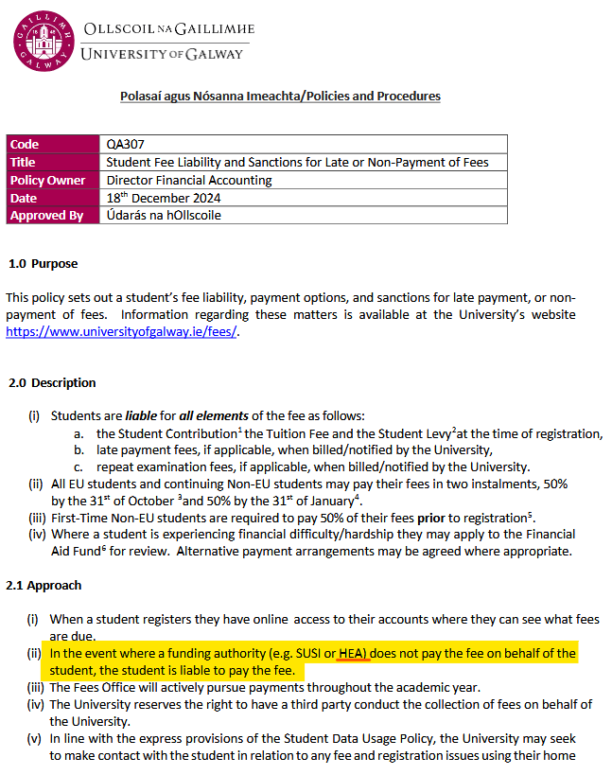

The best way for any student on any Springboard+ programme to prevent themselves being held personally liable for 100% of their course fees is to immediately comply with the Springboard registration timeframes in each semester, per the notifications that are issued via Canvas by the programme administrator.

The Springboard registration process for each semester involves four simple steps:
  - Log in to your account on the Springboard website.
  - Access your Applications list by clicking on your Username in the top right-hand side of the screen - you will see a drop-down menu. There you will see your Applications.
  - Click “Register” or “Re-register” (as applicable) for the programme in question.
  - Confirm Registration or Re-registration (as applicable) by clicking on “OK”.
--> Then the screen refreshes showing confirmed status.

As a reminder, the HEA deliberately block access to the Springboard website by anyone who is (a) outside the Republic of Ireland or who is (b) using a VPN.

Completing these registrations on the Springboard website when prompted to do so allows the HEA to make payments to the course provider and thus removes liability for payment of outstanding course fees from the individual student.

- How do I pay to the University the 10% course fees due from me as an employed participant under the Springboard+ scheme?
  - Pay fees - University of Galwayhttps://www.universityofgalway.ie/student-fees/pay-fees/?_gl=1*6itxtb*_gcl_au*MTIyMDMwNjg2NS4xNzUwMTQ1MTY0
- How do I contact the Fees Office?
  - https://www.universityofgalway.ie/student-fees/contact/

2.6 Leave of Absence
https://www.universityofgalway.ie/student-registry-helpdesk/leave-of-absence/
Springboard/HEA view any cessation of studies as the student not completing the programme in question and thereby forfeiting their Springboard-funded opportunity once and for all; they do not allow anyone to resume a funded place (i.e. with funding from Springboard still in place) following a break from their studies. If a student exits their programme and thus also exits Springboard funding for that academic year, liability for full course fees will revert to that individual student in the event they later decide to return and complete their programme in a future academic year (assuming the programme is still running at that time, which cannot be guaranteed).

2.7 Course Withdrawal
https://www.universityofgalway.ie/student-registry-helpdesk/our-services/coursewithdrawal/
If you find you must withdraw from the programme, please ensure you complete the University’s online withdrawal form no later than 31st October to ensure you leave with no impact on fees – link as follows:
- Postgraduate Students (Taught) online course withdrawal form
Please note: https://www.universityofgalway.ie/student-registry-helpdesk/our-services/coursewithdrawal/ “Students remain liable for fees up until the date on which they formally submit a withdrawal form online.”

The withdrawal guidelines also recommend that students should contact the relevant staff member for their College/School; for students on programmes run by the School of Computer Science the staff member to contact is the College of Science & Engineering’s Student Support Officer Kelly Moore https://www.universityofgalway.ie/cosestudentadvisor/. We recommend that you reach out to Kelly for advice and support as soon as possible.

Once the formal withdrawal has been processed on the University's systems, we will then update your status on Springboard's records to note for them that you have formally withdrawn from the programme via the University’s records. Students who have formally withdrawn should also contact Springboard directly via springboard@hea.ie to advise them of their formal withdrawal from the programme as well.

Please note: https://www.universityofgalway.ie/student-registry-helpdesk/our-services/coursewithdrawal/
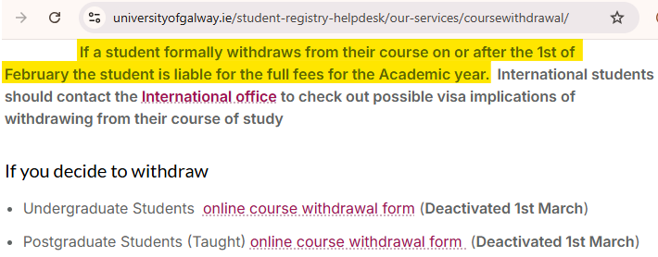

2.8 Student ID Cards
Students can collect their ID cards from the Student Registry Helpdesk, first floor, Áras Uí Chathail from the start of term: ID Cards - University of Galway. Alternatively, students can request their ID card to be posted - please email registration@universityofgalway.ie, note your ID number in the correspondence. To ensure your ID card reaches your address, please ensure that your term and home address on your student profile are correct.
Note: There is a fine of €20 if you do not have your Student ID card for verification of identity and registration in the exam hall.

2.9 Parchment Digitary Services
Parchment Digitary Services is a trusted, secure cloud platform that helps University students from around the world to access and share their verified academic documents online. This service will be used for official documents requests and letters from the Student Registry Helpdesk including: registration statements, course completion statement, transcript of results etc. Further details can be found at the following web link: Parchment Digitary Services - University of Galway

2.10 Maps
University of Galway Campus maps can be located on the University’s website at: https://www.universityofgalway.ie/buildings/maps/

2.11 Examinations
Results are no longer posted to the candidate's home address, they are now made available through the Parchment Delivery Service. These results will also be available on-line (following Semester 2 examinations)**. All other results will be available online only (following Semester 2 examinations).

Further copies of result transcripts can be obtained from the Student Registry Helpdesk.
Click on the link for info on how to register an address change. Please note you must allow 2 weeks for your change of address request to be processed.

** Some postgraduate results are not available online - check here (Examination Results Inquiry) for a full listing of course instances available online.

Results
Results will NOT be given on the telephone to candidates, or to anyone acting on their behalf.
Official Exam results release dates are available from the following Exams Office web link: https://www.universityofgalway.ie/exams/results/

Examination Timetables
Examination timetables may be viewed on the University of Galway web page at the following address: https://www.universityofgalway.ie/exams/timetable-advice/examtimetable/. Students personalised timetables will be available on the above link on a date to be advised by the Exams Office.

Timetables will NOT be posted to students.

Please be advised:
- Check the Amendments web page OFTEN as changes may occur up to day of exam.
- Revisions to timetables will be published only online.
- Revisions to timetables will not be posted to individuals or appear on personal timetables.

Repeat, Appeals and Re-checks
Where a repeat exam sitting is available for your course and if you fail the first sitting of a formal written examination, you are automatically listed to sit the repeat exam at the second sitting e.g. if you fail a Semester 2 Summer exam, you are automatically listed to sit the repeat exam in the Autumn. If you fail an exam/module which was not a formal written examination (e.g. essay, project, continuous assessment), please contact your Programme Director to discuss your options.

Springboard will not cover any repeat fees (either for individual repeat exams or for repeating an entire academic year) for any student under any circumstances, as that is wholly a matter between the student and the University and has nothing to do with Springboard.

All students who must repeat an exam (because of having failed it at the first sitting) can be charged a repeat exam fee by the University’s Examinations Office at the second sitting, which is payable by the student themselves - see link for further details: Repeat Fee - University of Galway

Please be advised that all repeat exams are capped at 40% in accordance with University policy: https://www.universityofgalway.ie/exams/results/repeat-capping/.
Note: Approved deferred exams are not capped.

Strict deadlines apply for appeals and re-checks and completed online application forms must be submitted to the Examinations Office by the relevant deadlines as detailed on the website links as follows: https://www.universityofgalway.ie/exams/results/appeals/ and https://www.universityofgalway.ie/exams/results/rechecks/. A fee must be lodged with both the Appeal and Re-check Forms. Fees are refunded if the outcome is positive. Further detailed information is provided in the above links.

Exam Board Sittings
The examination boards sit in June, September and October where relevant examination, project and theses grades will be processed by the College of Science and Engineering.

Deferral of Exams
A guide for exam deferrals is available at: https://www.universityofgalway.ie/exams/timetable-advice/deferrals/. This guide is to assist students with the process and provides a direct link to the College of Science & Engineering’s online specific Deferral Form.

2.12 Student Services
Coming to University is a major milestone in your life and a point of changeover in your life. You are facing into some challenges and many opportunities. You will encounter the enjoyment and challenges of independence and decision-making and responsibility for your own well-being and lifestyle.

Student Services is a team that are core to the personal and academic development of students. Student Services is under the management of the Vice President for the Student Experience. Student Services is committed to enhancing the individual student experience by providing an excellent service which supports the holistic development of the person, thereby enabling each student to achieve their full academic potential. Through valuing, recognising and supporting each staff member and by forging strong alliances within the University Community, Student Services will assist University of Galway to become a truly Student-Centred University.

Student Services provides many services as follows:
- Access Centre; Career Development Centre; Student Societies; Welfare and Wellbeing.

Further detailed information and contact details on all the Student Services offered by University of Galway may be found at: https://www.universityofgalway.ie/student-services/.

2.13 Student Counselling
The counselling service is part of a network of support services offered by University of Galway. It provides professional counselling, which is free and confidential to all students of University of Galway. Life as a student is exciting and challenging, an achievement usually gained after much hard work and preparation. It can also be stressful at times. You may find you are experiencing personal difficulties which are affecting your ability to study and to take full advantage of the opportunities available to you at University of Galway. This is where student counselling can help. Student counselling are a team of qualified and experienced counsellors and psychotherapists. The service operates within the Code of Ethics and Practice agreed by their respective accrediting bodies including IACP, IAHIP and PSI. The services provided include:
    - Pre-counselling assessment, individual counselling, and psychotherapy
    - Group work
    - Information and referral
    - A consultation service for those who may have concerns about a student.
Further information including available online services and emergency contact details can be located on the following weblink: https://www.universityofgalway.ie/counsellors/

Counselling Services: Location: No. 5 Distillery Road, University of Galway
Direct Tel: 091 492484 Ext. 2484
E-mail: counselling@universityofgalway.ie

2.14 International Students
The Global Galway Office provide advice, information and support service for all International Students. For incoming international students, information is available on: Global Galway - University of Galway

All international students are strongly encouraged to attend English for Academic Purposes (EAP) classes which are specifically designed to equip international students with specific English skills to help them with their studies. Please refer to https://www.universityofgalway.ie/englishlanguage/ for more details.

The Global Student Officer, Ms. Louise Kelly, may be contacted at Global Galway, University of Galway, Tel 353 91 493581, E-mail: louise.kelly@universityofgalway.ie. Louise Kelly acts as an identifiable point of contact with the various Student Services in the University to ensure that any problems of adjustment are minimised. Louise helps international students adjust as quickly as possible to their new environment, so that they can derive maximum benefit and enjoyment from their life at University of Galway.

2.15 Computer Science Account and Swipe Card Access to Labs
The School of Computer Science has several undergraduate and postgraduate rooms which are available for use by our students. The rooms have hot swap desks, with laptop docking stations allowing use of external monitor, keyboard, mouse and the high-speed network. Students must provide their own laptops https://www.universityofgalway.ie/science-engineering/school-of-computer-science/currentstudents/laptops/. All students who are taking a module/course with the School of Computer Science are entitled to use the open access labs in the CS Building outside of scheduled timetable use (Note: CSB-G001 is available to all University of Galway students using main University of Galway account). Depending on their course, they may also have swipe card access to further project rooms in the CS Building.

Computer Science students are also given access to print on our shared printers, and to use our web and database servers which can be used for course or project work. To gain access to these resources, students will be given Computer Science accounts automatically after a student registers for one of our modules/courses, and students will receive an email to their University of Galway email to indicate the account is ready for use. The initial password is included in the email. Students can login to our intranet to setup the web/database/linux resources https://web1.cs.universityofgalway.ie/intranet/

Students who have issues with their Computer Science computer account, docking stations, monitors or swipe card access in the Computer Science Building should log a call to Computer Science Technical Officers at: support@cs.universityofgalway.ie. Useful links for further related info: https://www.universityofgalway.ie/science-engineering/school-of-computer-science/currentstudents/.

Students who have issues with their main University of Galway account, Wi-Fi, Canvas, personal laptops or any PC/printer on the rest of campus should refer to the University of Galway helpdesk: https://www.universityofgalway.ie/information-solutions-services/services-for-students/.

2.16 DISC - Computer Programming Drop-In Support Centre
Computer DISC is a Computer Programming Drop-In Support Centre for all University of Galway students who are taking any programming/software development courses. The DISC is a free service that supports all students with their self-directed learning in computing topics at all years and levels in University of Galway. The centre is located in room CSB-1001 on 1st floor of the Computer Science (CS) Building.

What services does Computer DISC provide to students?
- Facilities for students to sit and work on programming problems
- One-to-one advice and support for students, and focused small group tutorials
- Books, courseware, web links, and other learning resources for programming students
- A website with information and an email service for all queries
- Advice for students who wish to learn new programming languages autonomously
- Assistance with new technologies for project work such as Final Year Projects
DISC Website: https://www.universityofgalway.ie/science-engineering/school-of-computer-science/currentstudents/computerdisc/

2.17 Canvas
Canvas is the Virtual Learning Environment (VLE) used at University of Galway. Canvas is a modern, user-friendly VLE that allows students to access learning materials, reading lists, assessment information and other course-related content.
https://universityofgalway.instructure.com/

When a student registers for a course or module with the University of Galway, they are automatically enrolled on the corresponding course on Canvas. Enrolments are recognised by Canvas within 24 hours of registration. If students have problems accessing Canvas, they should contact the Library and IT Service Desk. The Service Desk can assist students with queries regarding problems with their password, e-mail account or logging in to Canvas.

If students are unable to see courses when they log into Canvas, they will need to check their registration statement to ensure they are correctly registered. Within Canvas, University of Galway students have access to 24x7x365 support via the Help menu. This Canvas support team can answer most queries related to the Canvas environment including how to submit assignments, how to see the gradebook, and where to access course materials. They also provide advice on how Canvas features can be used.

2.18 Plagiarism
Plagiarism refers to copying another author’s work without due reference or acknowledgement of the author. Plagiarism is not acceptable. It is essential that the candidate acknowledge other people’s work, when used by the student. The submitted work must be prepared by the candidate alone, and must be the result of the candidate’s own effort, skills and knowledge. It is unacceptable for candidates to knowingly permit others to copy their work. Self-plagiarism (re-using own previously submitted content and passing it off as “new”) is also not permitted. It is also not permitted to submit content for assessment which has been produced using Artificial Intelligence and claiming it as your own work. University of Galway has a strict code of practice for dealing with plagiarism, please refer to the following link for further details: https://www.universityofgalway.ie/plagiarism/.

2.19 Information Solutions and Services (ISS)
ISS aim to provide students with access to the ICT facilities which they need to succeed in their studies at University of Galway. These facilities include high speed Internet access, a University of Galway email account, access to the resources of the James Hardiman Library and assist with accessing Canvas, the virtual learning environment. These services are accessible from the on-campus PC suites and from suitably equipped laptops using the on-campus wireless network. A Campus Account (CASS) provides students access using a single User ID and Password to all computing services, other than email. To activate your Campus Account (see paragraph 2.4 above), students should follow the instructions as outlined in the following weblink: https://www.universityofgalway.ie/information-solutions-services/studentrecordssystem/studentaccess/.

ISS Service Desk: Location: Ground floor of the James Hardiman Library
Contact by raising a service ticket: Service Desk Ticketing System
Direct Phone: 091 495777 or the Library & I.T. Service Desk: 091 493399

2.20 Career Development Centre
The Career Development Centre provides students at University of Galway with a quality career guidance and information service focused on facilitating and empowering students to manage their own career development and empowering students to make successful transitions towards fulfilling careers.

Details of the services provided to students by the Career Development Centre include:
Guiding students in their career journey through:
- One-to-one career guidance
- Career seminars and events
- Psychometric testing
- Dedicated careers information hub for students (on-campus and virtual)
- Self-guided modules
Connecting students with employers through:
- Jobs fairs and employer events
- Job vacancy system
- Networking opportunities
Helping students to compete in the jobs market to the best of their ability through:
- CV workshops, e-learning, and unlimited AI feedback
- Interview skills workshops, e-learning, and software to practice and improve
- Applications advice: including Postgraduate and Job Applications
- Employment skills workshops and employability award
Further information on the range of services provided by the Careers Development Centre can be found at: https://www.universityofgalway.ie/career-development-centre/
Career Development Centre: Location: Arts/Science Building (1st Floor)
Tel: +353 (0)91 493589

2.21 Out of Hours Working
Out of hours work refers to all University operations conducted outside normal hours.
For up to date details on the University’s Safety Statement Policy and Out of Hours Working, please click on the following web link: University of Galway Safety Statement

2.22 Parking on Campus
Parking spaces in University of Galway fall into several categories:
- Staff Only; Student Only; Shared use (staff & student permit holders); Visitor/non-permit holder; Pay-and-display/Pay by Phone (P&D) spaces; "Reserved" spaces and loading bays.
Student parking permits are available for registered students, details as below.

To purchase/renew your Student Parking Permit carefully read the instructions contained in the following guide ‌Parking Permit Application Guide then visit the Online Payment System to book your permit.

If you park in a "Pay and Display" space, you must buy a ticket from the nearby machines or use the Pay by Phone option and display your ticket on your dashboard face up, regardless of what other type of permit you might have. If you buy a P&D ticket, you can only park in spaces marked with blue lines and text (“P&D/Í&T”).

A park and ride service operates from Dangan car park. Further information and timetable details are available from: Parking & Transport - University of Galway.

Parking at University of Galway is operated by APCOA Ireland. If you have a parking related query, please contact: Ireland.permits@apcoa.ie / telephone: 0818 462899.

2.23 Library
The Student ID card also acts as a Library card. Students must have a current Student ID card in order to gain entrance to the Library. Details on the services provided by the library are available at Library - University of Galway. The Library and IT Service Desk are located on the ground floor of the library and provides advice and support to students on both Library and IT services (e.g., User ID/passwords, book loans, printing Wi-Fi access).

2.24 Module Descriptions and Assessments

Modules – Semester I

1PSD1 | Modules
Core | CT5229 Programming and Tools for Artificial Intelligence (CA) | Credits: 5
Core | CT5228 Principles of Machine Learning | Credits: 5

CT5229 Programming and Tools for Artificial Intelligence
This module is about programming and computational tools required for artificial intelligence. It uses the Python language as the main vehicle, but focusses on conceptual material rather than just the language itself. It moves fast through introductory Python workings. It covers several important Python libraries in detail, especially for numerical computing, machine learning, plotting, graphs. It discusses approaches to building re-usable, high quality code but not software engineering per se. It also visits some extra topics such as version control and introduction to the R language for statistics.

Assessment: First Sitting: Continuous Assessment 100%
Second Sitting: Continuous Assessment 100%

CT5228 Principles of Machine Learning
Machine Learning is concerned with algorithms that improve their performance over time, as they are exposed to new data. This module introduces learners to the different categories of machine learning tasks and provides in-depth coverage of important algorithms for tackling them. Its focus is on the theory underlying ML algorithms. In addition, the learners gain experience of implementing algorithms from scratch, as well as using ML software tools to select and apply these algorithms in applications, and they evaluate and interpret the results. Topics include: 1. Overview of Machine Learning & Major Categories of Task 2. Supervised Learning Principles and Information-Based Learning 3. Similarity-Based Learning 4. Evaluating Classifier Performance, Practical Advice, and Some Machine Learning Tools 5. Linear Regression in One and Multiple Variables 6. Linear Classifiers with Hard and Soft Thresholds 7. Probabilistic Machine Learning.

Assessment: First Sitting: Continuous Assessment 100%
Second Sitting: Continuous Assessment 100%

Modules – Semester II

1PSD1 | Modules
Core | CT5227 AI Model Deployment (CA) | Credits: 5
Core | CT5186 Future of Artificial Intelligence | Credits: 5

CT5227 AI Model Deployment (CA)
This module provides learners with a practical understanding of the methods, tools, and challenges involved in integrating AI and machine learning models into customer facing products from a software developer perspective. Efficient deployment of pre-trained machine learning models across a variety of environments including cloud services, web applications, mobile devices, embedded systems, and PCs will be taught.

Assessment: First Sitting: Continuous Assessment 100%
Second Sitting: Continuous Assessment 100%

CT5186 Future of Artificial Intelligence
This module aims to give learners an understanding of current trends in Artificial Intelligence (AI) and the future development of the field, covering both academic research and industrial deployments. The focus of the module will be on the challenges and opportunities that developments in AI present to individuals, organisations and society. Learners will gain experience of critiquing literature on AI and evaluating the technological readiness of various AI approaches to solve specific real-world problems.

Assessment: First Sitting: Continuous Assessment1 35%, Continuous Assessment2 15%, Project 50%
Second Sitting: Continuous Assessment1 35%, Continuous Assessment2 15%, Project 50%

Modules – Semester III

1PSD1 | Modules
Core | CT5230 Capstone AI for SW Project | Credits: 10

CT5230 Capstone AI for SW Project
The module serves as a bridge between academic knowledge and practical application, preparing students for seamless entry into the professional sphere, either through hands-on experience in industry or intensive team work in capstone project. The module promotes the research based and team based practical learning.

Assessment: First Sitting: Project 100%

